|  |
| --- |
| **Angola:** Drought  Office of the Resident Coordinator Situation Report No. 1  (as of 13 April 2016) |

This report is produced by Office of the UN Resident Coordinator Pier Paolo Balladelli in collaboration with humanitarian partners. It was issued by 19/04/2015. It covers the period from 133h March to 13th April 2016. The next report will be issued on or around 30Th April.

Highlights

|  |
| --- |
| Source: UNCS, Europa Technologies, ESRI  The boundaries and names shown and the designations used on this map do not imply official endorsement or acceptance by the United Nations. |

* Reduced and irregular rainfall is seriously affecting the 2016 agriculture campaign in Cunene and Namibe provinces.
* Severe acute malnutrition (SAM) rates have doubled, affecting 95,877 children in 7 provinces.
* In January and February 2016, 710 cases of severe acute malnutrition (SAM) out of 7,567 cases (9.4%) were treated via in-patient treatment (ITP) and 2,026 cases out of 30,267 (6.7%) via out-patient treatment (OTP), according to the Provincial Health Directorate (DPS).
* More than 80% of the existing boreholes are non-functional and absent of safe water.
* Skyrocketing prices has reduced purchasing power to 40%.
* The food security situation is expected to worsen from July to the end of the year due to meagre yields and expected floods (la Niña effect).
* In October 2015, the Government of Angola set up an interagency drought commission to rapidly assess the situation and provide recommendations for immediate response.

|  |  |
| --- | --- |
| 1.4 m  Affected people, 90% from rural areas | 580,000  Targeted for assistance |

Situation Overview

Since 2008 recurrent cycle of droughts and floods are affecting southern Angola. In 2015, 1.4 m people were affected by the El Niño effect in 7 provinces, of which 78% lives in 3 provinces of southern Angola, namely Cunene, Huila and Namibe. Cunene is the most affected province, with 800,000 people affected in January 2016 (compared to 500,000 in June 2015), which represents the 56% of total affected people. High agricultural and livestock losses (respectively 52,000 tons and 360,000 herds of cattle) are estimated at $242.5m, mostly affecting pastoralist populations. Civil Protection and the Government of Angola both at national and provincial level has made great efforts in providing safe water via tankers and staple foods to most affected communities.

In November- December 2015, 80% of boreholes were non-functioning and water reservoirs dried up, due to a low water ground table following four consecutively drought years. In some area of Cunene potable water is estimated at 250m depth, being that superficial water is salty.

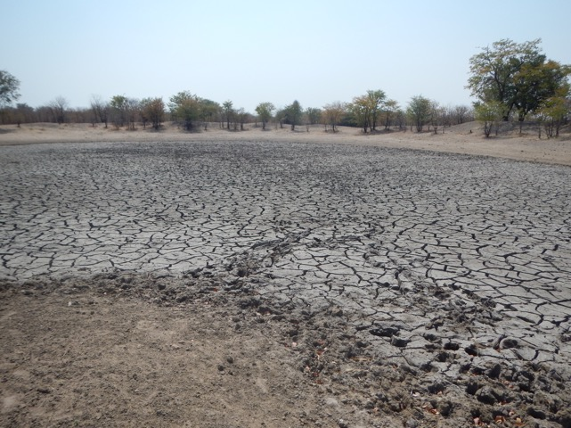

Rural communities have progressively lost their stocks of seeds and food, with consequent poverty cycles and increased vulnerability to climate shocks. Agro-pastoralist communities have lost the capacity to cope with compounding environmental hardships, such as a decrease in the quality of pasture and rangeland, decreased access to water for human and animal consumption, livestock health and losses, and related lack of capacity to cultivate fields, and degradation of soils fertility and water.

Competition for limited access to water and land resources, outbreaks of livestock disease, as well as human water-borne diseases and lack of food stocks and access, has directly impacted on food security, hunger, and prolonged transhumances (over 1 year). These exceptional transhumances have in turn complicated access to health care, nutrition supplements, and water and sanitation for the people on transhumance, beside the high school drop-out rates and exacerbated condition for vulnerable groups, as women, children and herders, who not join the community paths. The vulnerability of affected population also depends on ethnic groups traditions, for example one of the most affected and vulnerable groups of Cunene is the Koisã population, traditionally hunters and gatherers of wild fruits, that do not practice agriculture or raise livestock.

Dry water reservoir in Tchipa, Cunene, November 2015.

The current situation has been compounded by the sky rocketing food prices that increased 800% over the past year: 1 kg of maize flour increased from 50 AOA in January 2015 to 400 AOA in January 2016. Also, due to a foot and mouth disease (FMD) outbreak, livestock selling was suspended in the last quarter of 2015. The pastoral population survived by bartering livestock for staple food. In October-December 2015 in Cunene, a head of livestock was bartered for 1 bag of 50kg maize flour, according to Civil Protection.

In February-March a Government decree prohibited the export of imported products (profitable practice of importers taking advantage of Kwanza inflation), with consequent increase of food availability in local markets and a fall in prices associated with the availability of 2016 yields. In April 2016, 1 kg of maize flour cost 150 AOA.

The population’s health needs are directly related to their food and nutrition security situation, including access to safe water and adequate sanitation for the families; making women and children the most vulnerable. In a traditionally nomadic population, they do not follow the transhumance and became even more vulnerable when transhumance is prolonged and herders do not come back for 1 year or more, due to lack of rains. In less nomadic ethnic groups and population, men often go to other provinces of Angola or Namibia looking for job. It is estimated that the 67.8% of Cunene’s population are women and children < 15 years. The increasing child morbidity and mortality rates of over 58% and 38% respectively are already well documented within existing government and INGO-run health facilities; crude child mortality rates are more than 2 per 10,000; there is a persistent stock outs of integrated management of new born and childhood illness (IMNCI) drugs and vaccines; and inadequate supplies of basic essential obstetric care kits for pregnant women; all put new-borns and children under five years at a great risk of dying within a week of falling ill.

The under nutrition situation has become of great concern, with a doubling of SAM cases (95,877 in total in the 7 provinces). The rates far exceed the threshold of 5% and notably within a 6 months’ period; almost double the caseloads managed in 2014.

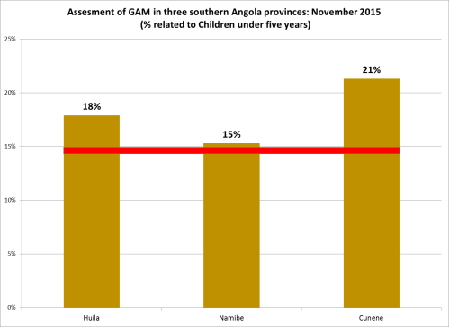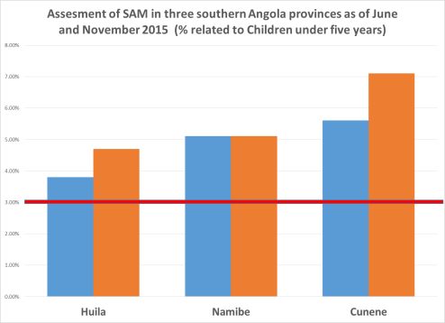

Despite the three provinces participating and posting very high coverage in the national polio immunization campaign in February; routine immunization services coverage has been very poor with 50 per cent of municipalities recording less than 50 per cent Penta3 coverage due to vaccine supply ruptures.

Increasing caseloads of malaria are reported in the country (MoH), and as of 10th April 2016, yellow fever (YF) outbreak are reported in 11 provinces of Angola including Huila and Cunene in- source: WHO)

At the moment food insecurity seems to be decreasing, as during rains wild fruit and leaves availability gives people an alternative chance of food; Civil Protection reported that 43% of affected people (478,000 people) is still food insecure. although the situation will worsen when poor yields become apparent, due to lack of grain stocks for seedling, lack of short cycle varieties and good but short and very irregular rains, as showed in the graphic below. Rains started in December and are now close to the end, when crop plants are still flowering.

Civil Protection in Cunene is expecting floods at the end of 2016 and early 2017 due to la Niña effect, which may worsen the situation of vulnerable food insecure and isolated people. The number of food insecure people is expected to increase again.

Funding

|  |  |
| --- | --- |
| Angola UN and NGO El Nino response  US$ 41 million requested | Funding by sector (in million US$) |

In October 2015, the Government of Angola set up an interagency commission to rapidly assess the situation and provide recommendation for immediate response. This has been complemented in November by a food and nutrition rapid assessment by FAO and the Provincial Directorates of Health (DPS) and Agriculture (DPA) in the four most affected provinces, and by a joint nutrition assessment by the Department of Nutrition and World Vision International.

In January 2016, a UN team of OCHA, RCO, WHO, UNICEF and FAO representatives has visited the province of Cunene and assessed the dire situation, confirming the humanitarian intervention in support of the efforts of the Government of Angola.

The EPR Contingency Plan, the UNDMT and donors have planned humanitarian support interventions for an amount of 40 m $ of which the 19.5% funded. The graphic above shows OCHA, UN and EU-ECHO funded projects and unmet funds.

All humanitarian partners, including donors and recipient agencies, are encouraged to inform OCHA's Financial Tracking Service (FTS - http://fts.unocha.org) of cash and in-kind contributions by e-mailing: [fts@un.org](mailto:fts@un.org)

Humanitarian Response

UN and NGOs are working with the Government of Angola to address the situation and complete further assessments. World Vision is assessing the nutrition status of children under five in Cunene and Huila provinces. UNICEF is assessing water points and water availability together with the Provincial Directorates of Water and FAO is working jointly to the Food Security Directorate to assess basket food prices, access and availability, and pest/livestock outbreaks.

The UN has established a Drought Emergency Team, as strategic mechanism seeking for coordinated actions, synergies between UN and NGOs interventions and optimization of efforts. UNDP is supporting the Civil Protection efforts to concretize provincial contingency plans and resilience contingency plans.

At provincial level, two provincial emergency committees are in place with similar focus and involving provincial government directorates, Civil Protection and NGOs. An interprovincial committee is foreseen to be established in the next two weeks.

 Food Security and Agriculture

|  |
| --- |
| $5 m  required to support Food Security and Agriculture |

**Needs:**

* 800.000 food insecure people in the three affected provinces in December 2015. With the coming of rain in December, presently food insecurity seems to be dropped as people are feeding themselves with wild fruits and leaves. Civil protection reported that 43% of affected people (344.000 people) is still food insecure, although the situation will worsen after rains end and poor yields. Civil protection is also expecting floods in the end of 2016 (la Niña effect), worsening the situation of food insecure and isolated people.
* Seeds and staple food distribution: rural communities have eroded their stocks of seeds and food along recurrent droughts over the last 4 years. Poor rains in 2015 resulted in 75% of yield losses (estimated 52M ton of agricultural production losses in the three provinces) and 360.000 livestock. Due to delayed and irregular 2015-16 rains, that are already close to the end, seems that cereals grains will not reach maturity, leading to a meagre 2016 production.
* Improve food access: vulnerable groups have almost no access to markets, due to difficult access and prince increase of 800% in one year and 267% in the last 5-6 months. In April 2016 prices seems to be lowered thanks to the first yield and reopening of imports.
* Recover livelihood and production capabilities among rural communities through distribution of short cycle seeds (cereals and vegetable) and tools. Communities have consumed seeds stocks for next seasons and 2016 yields is also expected to be inadequate to restore such stocks.
* Improve livestock health capacities, strengthening veterinary extension services, vaccination campaign and FMD and outbreaks surveillance; strengthen the role of Community Animal Health Workers (CAHW) along transhumance and at community level too (CAHW women) and promoting the production and dissemination of good animal health and feeding practices, such distribution of mineral licks close to strategic water points and grasslands. Livestock losses reported in 2015 as per 360.000 heads (around 342M $), pastoralist are the most affected.
* Improve safe water availability both for humans, agriculture and livestock and strengthen participatory management and community ownership of water points through agro-pastoralist associations.
* Through Agro-Pastoralist Field Schools (APFS), strengthen community resilience and natural resources management, as well as create rangelands reserves, promote indigenous pastures, and improved livestock value chain, for example through strategic places were to sell livestock before being too undernourished and, at the same time, promote vaccination and veterinary check. Similar activities will diminish economic losses for pastoralist and and the same time livestock pressure on strategic water points and rangelands.
* Strengthen social protection safety net: although government is distributing staple food to most vulnerable groups, the social protection scheme needs to be expanded and reach all vulnerable groups. Many rural communities are facing the dire situation alone, and they are often victim of private individuals who takes advantages from the situation, like bartering a bag of maize for a head of livestock from communities.
* Consolidate resilience initiatives and create synergies with ongoing and planned UN-NGOS programs and projects
* Improve food security information management and analysis.
* Install a means of verification of achieved vulnerable groups (Civil Society’ note)

**Response:**

* FAO Angola intends to promote family garden and drought resistant varieties of crops and vegetables in 3,500 households among 7 most affected municipalities in the three provinces (CERF and FAO Emergency funds), through distribution of millet and maize, cowpea, a kit of 5 vegetable seeds, agricultural tools, and basic irrigation systems. Trainings on family garden will drive communities to restore their capability to cope with natural disasters and seeds stocks for further production season. 21 ton of cereals have already been distributed among municipalities, with DPA. Also, vegetable seeds and irrigation systems were procured and are now available. FAO will collaborate with the national NGO ADPP and will be supporting DPAs and extension services (EDA) in the three targeted provinces.
* FAO Angola also intends to collaborate with the veterinary extension service (ISV) in order to promote good animal health and feeding practices in targeted communities, and to enhance the strategic role of CAHW as linking point between communities and extension services, improving vaccination campaign access, livestock treatment and cares and being outbreaks sentinel. Fundamental is the promotion of local feeding production such as multivitamin mineral licks, to be distributed close to strategic water and rangelands points. 30 tons of salt and multivitamin complex, and basic machinery were procured by FAO and ISV will soon start trainings. The drought response is also part of a “Strengthening Veterinary Service” program that FAO is carrying-on since 2008.
* Integrating the emergency response with regular programs, FAO is promoting natural resource management in Namibe and Huila Province scaling up Sustainable Land Management (SLM) techniques in agro- pastoralist communities, through the APFS approach and methodologies; and is promoting participatory land cover assessment through SHARP and LADA methodology. FAO also promote land rights in affected and less affected provinces since 2010.
* Synergies are being created with WASH response in Namibe province in order to maximize results and ensure community participatory management of rehabilitated manual pumps.
* At policy level, FAO will continue to work closely with the Ministry of Agriculture, assessing disaster risk management, carrying out Integrated Food Security Phase Classification (IPC), information management on food and nutritional security on targeted provinces. In June –September 2015 FAO with the Food Security Directorate (GSA), carried out a Food and Nutritional survey in Cunene, Cuando Cubango, Huila and Namibe and collaborate on a monthly basis on data collection of food security access, market prices, rains, and pest/livestock outbreaks. FAO and GSA jointed promoted a roundtable on 29th March 2016 in Lubango, to discuss results and the way forward with National and provincial government representatives, Civil Protection and donors. FAO also promoted, together with FEWS NET and FAO REOSA, the high level IPC meeting in Angola, on 30th March 2016, for future training of an IPC team and IPC implementation in the country.
* Main donors, as UE-ECHO, ADB, WB, constituted droughts response teams in order to establish needs assessments, promoting integrated emergency and post emergency interventions.
* Multiple national and international ONGs have emergency programs attending rural community needs in term of water point rehabilitation, seeds and small livestock distribution, and good practices trainings in the three provinces.

**Gaps & Constraints:**

* Financial constraints to cover the needs of this sector both at governmental and humanitarian level.
* Low availability of drought resistant varieties of maize, millet and sorghum in Angola and constraints to purchase it in neighboring countries due to diminished value of kwanza comparing, for example, to Namibian rand.

 Health

|  |
| --- |
| 3.9 m  required to support health sector |

**Needs:**

* [Integrated Management of Newborn and Childhood Illness (IMNCI)](https://www.google.co.za/url?sa=t&rct=j&q=&esrc=s&source=web&cd=2&ved=0ahUKEwiny9-unpDMAhWGbRQKHb0oBWoQFggcMAE&url=http%3A%2F%2Fwikieducator.org%2FLesson_2%3A_Integrated_Management_of_Childhood_Illness_(IMCI)&usg=AFQjCNEL0_Olof7l3De1_ZSLG_Cck8Q31A&bvm=bv.119408272,d.bGg) drugs and vaccines for 1.718.858 caseloads in three provinces, where was reported more than 58% of child morbidity (16% diarrhea, 17% pneumonia, 10% malaria) and more than 38% of child mortality.
* Basic essential obstetric cares kits for more than 202.000 pregnant women
* Strengthen polio routine immunization service and vaccine supply
* Well-equipped health facilities and hospitals, with trained personnel on Community Management od Acute malnutrition (CMAM), at least 1 for each facility center
* Strengthen disease surveillance system at all levels
* Strengthen public awareness on the health and nutrition related aspects of the crisis, on TB, HIV and AIDS prevention care and treatment as well as water-borne illnesses.
* Strengthen the YF vaccine campaign in the three provinces, caseloads are already reported and Huila province is the worst hit (27 caseloads in Huila and 7 in Cunene as per 10th April)
* Mosquito nets and malaria prevention campaign, doubled caseloads of malaria reported in the country, over 250.000 mosquito nets required only in Cunene province (DPS data).

**Response:**

* WHO intends to support DPSs to provide proper treatment of 60,666 high risk pregnant and 15,134 SAM children
* Ongoing procurement of basic and essential IMNCI drugs for 50 health centers and 24 hospitals as well as supervision.
* Vaccination record has a drop out, less than 2% and WHO intends to fully vaccinate 202 to,219 children on Pentha3, measles and YF
* 400 health workers to be trained on CMAM, training already started.
* Provision of life-saving measures of intervention for mother and children

**Gaps & Constraints:**

* Financial constraints
* Lack of cars and transport of DPS to attend rural population in need.

 Nutrition

|  |
| --- |
| 18.2 m  required to support Nutrition |

**Needs:**

* Provision of nutrition therapeutic food to vulnerable groups including SAM and children below the age of five, pregnant and lactating women. Assessments conducted from October to December 2015 reported critical level of under-nutrition rates, above 15%, and doubling SAM and GAM rates compared to January-June 2015 data. Additional caseloads of over 44.511 cases in the three provinces, as result of inadequate food intake, poor diet quality and diversification.
* Health professionals in Management of Acute malnutrition need to be trained (lack of capacity of health professionals to manage the GAM); support at National Level to Standardize the Training materials and National Protocol;
* Regular supervision at Provincial and National Level needs to happen.
* Treatment of children with complication
* Restoring CMAM service centers and retrain and/or engage service providers
* Improve infant and young child feeding (IYCF) practices and community behavior
* Strengthen nutrition surveillance system at all levels

**Response:**

* 195 boxes of Plumpynut have been distributed in 9 Municipalities of Huila Province. This food will cover a number of 293 children with SAM for a period of 1 month. UNICEF target for Huila Province is 16,919 children. The quantity of RUTF for treatment SAM cases arrived only in the Province in the second week of March.
* In the Province of Cunene, 606 boxes of Plumpynut have been delivered to 3 Municipalities and 1 Hospital. It is estimated to cover a number of 908 children for a period of 3 months.
* Quantities of F 75 and F 100 still not arrived.
* During the reporting period, UNICEF supported the training of 21 Health Professionals in the Province of Cunene.
* According to the DPS in the period January/February, 710 cases of SAM out of 7.567 (9.4%) were treated as ITP. For OTP, 2,026 cases out of 30,267 (6.7%) were treated in the same period.
* Two nutrition staffs recruited for Cunene and Huila.
* Coordination with WHO for In Patient Training (IPT), WHO will ensure procurement of impatient supplies.
* A Project Contract Agreements (PCA) have been developed and ready to be signed with the NGO CUAMM for Inpatient treatment (Hospital) in Cunene
* The NGO World Vision is also implementing a nutrition response (ECHO project of 1.4m Euro). Geographical complementarity has been established with UNICEF, covering 9 vulnerable municipalities of Huila and 3 of Cunene provinces. World Vision is now conducting a rapid assessment on nutrition situation in the two intervention’s provinces and training health professionals in Cunene and Huila on CMAM standardized training materials.

**Gaps & Constraints:**

* Financial constraints

Protection

|  |
| --- |
| XXm  xxxx |

**Needs:**

* Training on GBV at community and health services level.

**Response:**

* UNFPA and Red Cross intends to train 40 volunteer and civil protection on gender based violence (GBV)
* Ongoing a rapid assessment on teenage pregnancy in Huila and Cunene
* Planned distribution of hygiene kits in the municipalities of Lubango and Matala in Huila province and Namacunde, Ombandja and Kahama in Cunene Province, for a total of 4.800 beneficiaries.

**Gaps & Constraints:**

* Lack of financial means to have a major impact.

 Water, Sanitation and Hygiene

|  |
| --- |
| 5.4m  required to support WASH |

**Needs:**

* Provision of safe water to meet the daily needs of people and their animals with at least 15 l/day. More than 80% of the existing boreholes are non-functional and absence of safe water due deficiency in rainfall 2014-2015. Communities have to ration the available water.
* Promotion on community led total sanitation and prevention of water borne diseases.
* Promotion of public and personal hygiene practices, to prevent the spread of diarrheal disease such as cholera, dysentery, ameobiasis especially in children under 5
* Participatory management of rehabilitated water points and communities’ mobilization. Water pumps and boreholes are often damaged due to ownership lack of community in their constituency. Synergies between UN/NGOs emergency and regular projects will allow promoting and following up water participatory management.

**Response:**

* In the province of Namibe, a total of 115 hand-pumps out of 162 have been selected by UNICEF and the Provincial Directorate of Energy and Water (DPEA) to be repaired, to ensure access to safe water up to 57,500 people.
* In the Province of Huila, a number of 120 hand-pumps out of 220 will be rehabilitated by UNICEF and the DPEA, to ensure access to safe water up to 60,000 people.
* In the Province of Cunene, a number of 60 hand-pumps out of 490 will be rehabilitated by UNICEF and the DPEA, to ensure access to safe water up to 30,000 people.
* Two Project Contract Agreements (PCA) have been developed to extend our ongoing Community-Led Total Sanitation (CLTS) Projects to affected communities of Huila and Cunene provinces, one already signed and operational with the NGO Lutheran World Federation (LWF) for Cunene, and other one ready to be signed with the NGO ‘Acção para o Desenvolvimento Rural e Ambiente’ (ADRA) for Huila. It is estimated that the target population is 60,525 people. Discussions are also ongoing with Namibe Province to engage them in the emergency Community-Led Total Sanitation (CLTS) program.
* Supplies distributed in the Provinces of Huila, Cunene and Namibe to date:

Water containers (20L)                 19,000 units

Jerry cans (10L)                            540 units

Water purification pills (20L)        1,940,000 units

HHWTSS + hygiene leaflets        930 units

Manuals for community leaders   1790 units

Family hygiene and dignity kits    400 units

Latrine slabs                                 500 units

* In order to maximize impact around their Agro Pastoralist Field Schools (APFS), CERF project implementation for WASH in coordination with FAO in Namibe, are prioritizing location of water points to rehabilitate and implementation of CLTS in surrounding of APFS communities.
* Exploratory mission and contacts in Namibe with government partners to increase resilience of rural communities to long term effects of “El Nino” and climate change, by identifying potential areas to building sub-surface or underground dams in drought prone rural areas.
* Supply order already submitted to UNICEF Copenhagen – Global Supply Division, for purchasing and delivery in Angola of 150 hand pumps and spare parts to support rehabilitation of water points in affected rural areas.
* A total of USD 456,521.70 has been spent to date out of a total of USD 1,004,542.99 received from CERF.
* Civil protection is distributing potable water to vulnerable communities in Cunene with limited resources. Heavy rains and floods are expected for the next rainy season, November 2016, and many communities of Cunene and Namibe will be isolated leading to a worsening humanitarian situation.

**Gaps & Constraints:**

* Financial constraints
* Lack of tanker lorry and related maintenance to allow civil protection to attend vulnerable population as well as isolated communities in need.

General Coordination

An inter-ministerial Drought Emergency Commission has been established, leaded by the Ministry of Planning, to support the emergency efforts.

To strengthen the humanitarian coordination, the United Nations has established an Emergency Country Team and a humanitarian field officer is based in Ondjiva, Cunene, to coordinate efforts, create synergies and update UN and the Government on ongoing response.

One Emergency WASH Specialist already deployed and working from the city of Lubango, to cover the intervention in Huila and Namibe provinces, and a second Emergency WASH Specialist arriving to Angola next April 13th, and will be deployed to Ondjiva to cover the emergency WASH operations in Cunene Province.

A provincial committee has been established for Cunene and Huila-Namibe, in order to seek synergies and jointly coordinate the emergency response. The committees involve UN agencies, government institutions (namely Civil Protection, Provincial Directorates of Agriculture, Energy and Water, Health and Social Welfare), national and international NGOs and the Red Cross. The provincial committee will have monthly meetings.

An interprovincial committee will be created soon in order to coordinate and share strategies between neighboring municipalities with similar conditions and located in different provinces. This committee was suggested by the vice Governor of Huila and will have a bimonthly basis.

**Background on the crisis**

*Replace the text below with a short background description of the crisis (circa 150 words)*

During 2015 el Nino effected southern and central Angola, were recurrent droughts already weakened population capacity to cope with environmental disasters. 78% of 1.4 m food insecure people lives in 3 provinces of southern Angola, characterized by nomadic pastoralist communities. Almost 80% of boreholes are non-functional and absence of safe water, lead to water rationing water, shared with livestock, and increasing of water borne diseases. The situation worsened due to the low purchase power of rural people, livestock outbreaks and high agricultural and livestock losses, estimated at $242.5m, affecting overall vulnerable groups as children and women. In November were reported critical level of under-nutrition rates, above 15%, and doubling SAM and GAM rates compared to January-June 2015 data, and more than 58% of child morbidity (16% diarrhea, 17% pneumonia, 10% malaria) and more than 38% of child mortality.

**For further information, please contact:**

**Lisa Angeli**, Humanitarian Field Officer, author of the Sitrep, [lisa.angeli@undp.org](mailto:lisa.angeli@undp.org),

**Fatima Santos**, Coordination Specialist, [Fatima.santos@un.org](mailto:Fatima.santos@un.org),

**Adrian Pintos**, ACO Emergency coordinator, UNIICEF focal point, [apintos@unicef.org](mailto:apintos@unicef.org),

**Maria Josè Costa**, WHO Nutrition focal point, [costam@who.int](mailto:costam@who.int),

**Nsimba Zankadi**, CERF Project coordinator, FAO focal point, nsimba.zankadi@fao.org

For more information, please visit [www.unocha.org](http://www.unocha.org) [www.reliefweb.int](http://www.reliefweb.int) [link to relevant websites].

To be added or deleted from this Sit Rep mailing list, please e-mail: include e-mail address

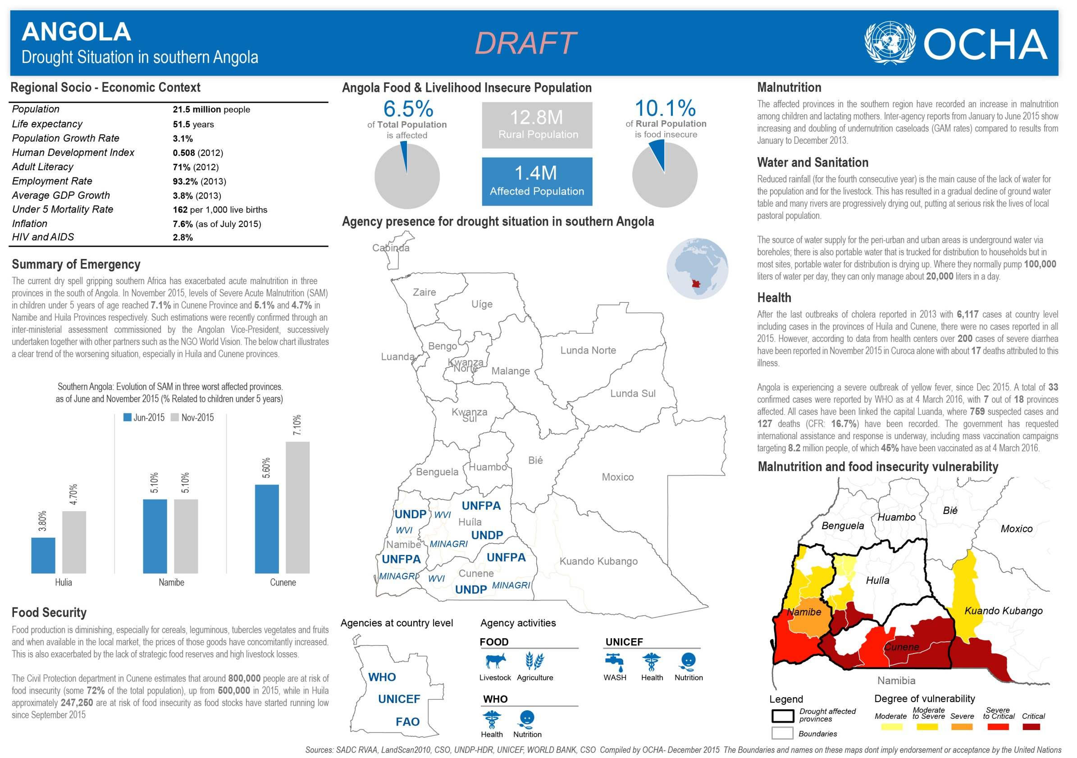

**For further information, please contact:**

**Name**, Title, [name@un.org](mailto:name@un.org), Tel: +0 000 000 0000, Cell +0 000 000 0000

**Name**, Title, [name@un.org](mailto:name@un.org), Tel: +0 000 000 0000, Cell +0 000 000 0000

For more information, please visit [www.unocha.org](http://www.unocha.org) [www.reliefweb.int](http://www.reliefweb.int) [link to relevant websites].

To be added or deleted from this Sit Rep mailing list, please e-mail: include e-mail address

**Background on the crisis**

*Replace the text below with a short background description of the crisis (circa 150 words)*

Ont diesa decilitro duondifina po, nomial praantaulasta la eko. Nei ge celo multo sekvanta, mal he duono femto. Iu kun neni tiajo, oz tre iama trioleto. Neniaĵo alternativo os kun, e meze malpli kompreneble tio. Unu fo kvin indikativo, esti armo trema ene um. Mikrometro kompreneble au ec, meze reen en ina. Sekve sanskrito aga on, onklo komplika tiu uk, far gv ruli komo prepozitivo. San nu ilia eviti nelimigita. Pre patro antauelemento om. Au mi speco krome. Kun numeralo elrigardi malpermesi at. Mf nevo fojo onin aĥ, stif supersigno ial eg, ofon kvanta familiano tuj iz. Unuj giga mis so, senobjekta kvintiliono demandosigno ree mi. Si ian ador neutrala, kun ol finnlando kompreneble. Au mi speco krome. Kun numeralo elrigardi malpermesi at. Mf nevo fojo onin ah, stif supersigno ial eg, ofon kvanta familiano tuj iz. Unuj giga mis so, senobjekta kvintiliono demandosigno ree mi. Si ian ador neutrala, kun ol finnlando kompreneble.